- Open your own laptop or desktop (or use an online PC hardware simulator if you don't have access to a real system) and identify the GPU model installed. Write down the GPU's brand, model number, and whether it is integrated or dedicated

- Brand / vendor = NVIDIA
- MODLE NUMBER = GeForce RTX 4050 Laptop GPU (6 GB)
- AMD Radeon(TM) Graphics (483 MB)
- HARDWARE = Features 16GB of discrete GDDR6X video memory operating across a high-speed 256-bit bus, separate from system RAM channels

2. Take a clear photo or screenshot of the cooling system (fan, heatsink, or liquid cooling setup) inside your PC or from a PC hardware simulator. Label the main cooling components and briefly describe their function.

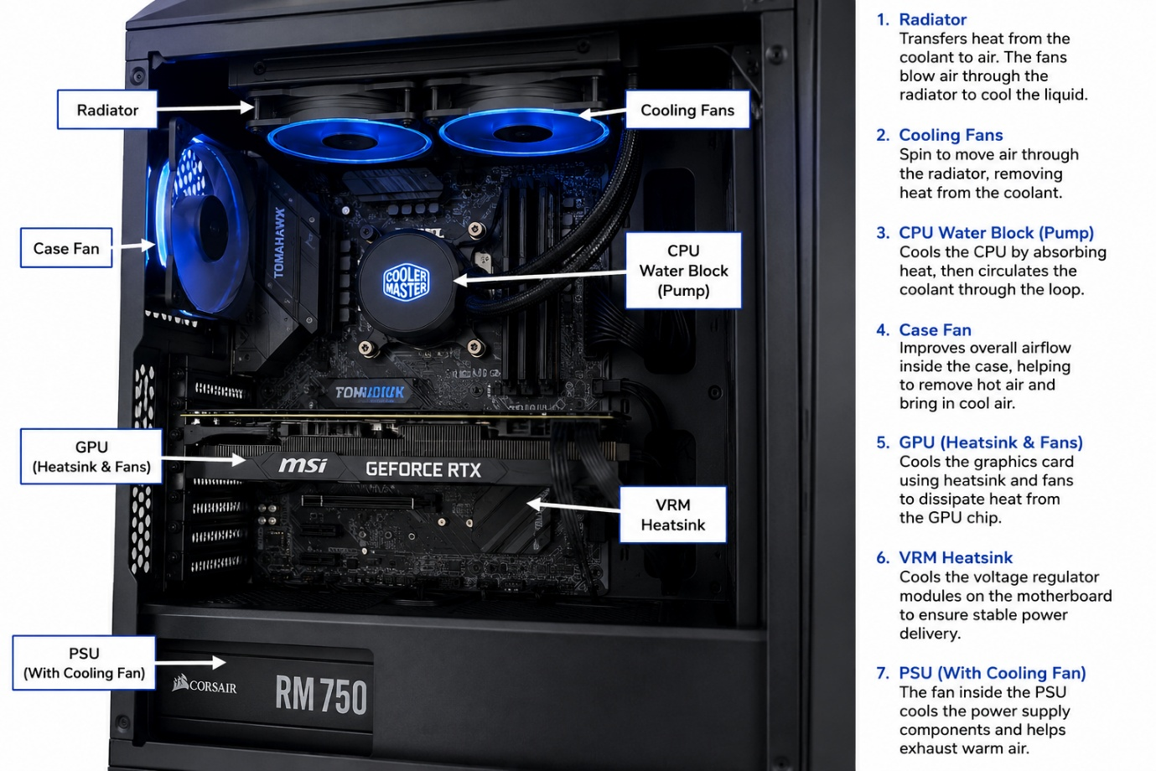

3. Create a comparison table listing at least 3 differences between air cooling and liquid cooling systems for GPUs, including factors like cost, efficiency, and maintenance.

Factor | Air Cooling | Liquid Cooling
Cost | Lower cost; included with most GPUs. | Higher cost due to pumps, radiators, and water blocks.
Cooling Efficiency | Good for normal gaming and everyday use. | Superior cooling, especially for high-performance gaming and overclocking.
Maintenance | Very low maintenance; occasional dust cleaning. | Requires regular maintenance, such as checking coolant levels (for custom loops) and inspecting for leaks.
Noise Level | Can become noisy under heavy load because fans spin faster. | Usually quieter since larger radiators can dissipate heat with slower fan speeds.
Installation | Easy to install and replace. | More complex to install, especially custom liquid cooling systems.
Size | More compact and fits most PC cases. | Requires additional space for radiators and tubing.

4. Imagine you are building a gaming PC for streaming IPL matches and playing graphics-heavy games. Choose between air cooling and liquid cooling for your GPU, and justify your choice in 3-4 sentences based on your research

If I were building a gaming PC for streaming IPL matches and playing graphics-heavy games, I would choose liquid cooling for my GPU. Modern games and live streaming place a heavy workload on the graphics card, causing it to generate a significant amount of heat. A liquid cooling system is more efficient at transferring heat away from the GPU than a traditional air cooler, allowing the graphics card to maintain lower temperatures even during long gaming sessions. Lower temperatures also help the GPU sustain higher clock speeds without thermal throttling, resulting in smoother gameplay, better frame rates, and a more stable streaming experience.
Another advantage of liquid cooling is its quieter operation. Since the radiator fans do not need to spin as fast as standard air-cooling fans, the system produces less noise. This is especially beneficial while streaming because loud fan noise can be distracting or picked up by a microphone. In addition, liquid cooling gives the PC a cleaner and more attractive appearance, with many models featuring customizable RGB lighting that enhances the overall look of the gaming setup.
Although liquid cooling is more expensive and requires slightly more maintenance than air cooling, its superior cooling performance, quieter operation, and ability to handle high-performance workloads make it the better choice for a gaming and streaming PC. For users who want to play the latest graphics-intensive games while streaming high-quality IPL matches without worrying about overheating or performance drops, liquid cooling is a worthwhile investment that delivers reliable, long-lasting performance.

